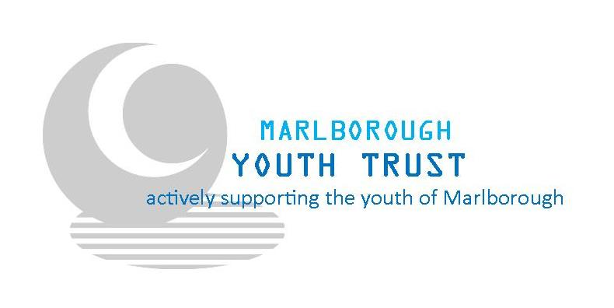

Marlborough Youth Trust
Youth Advisory Group Application

Marlborough Youth Trust is looking for 12 – 24 year olds who like to communicate and engage, have passion and are willing to lead and learn! The Youth advisory group will be more involved in their local communities, decision making and give youth a voice in everything that we do. Through being involved in the Youth Advisory Group you will also have the opportunity for development through different courses and training.
No experience is needed, we are looking for a diverse group of people who are driven, passionate and seek to create a positive change in Marlborough!

For more information please Contact: Ginny Young
MYT Youth Worker
Ph: 03 579 3143
Cell: 027 522 2243
Email: youthworker@myt.org.nz

Name:
Age:
Ethnicity:
Phone Number:
Email:

What part of Marlborough do you live in?

Drivers Licence (select one):
- Unlicensed
- Learners
- Restricted
- Full

How did you hear about the Youth Advisory Group?
- School Assembly Talk
- School Newsletter
- Newspaper
- Social Media
- Website
- Word of Mouth

What are your skills and Interests?

Tell us why you would like to be in the Youth Advisory Group:

What could you bring to the Youth Advisory Group?

Tell us about other things you do/are a part of:

Referee:
Relationship to you:
Phone Number:
Email:

Thank you for your interest, Applications close on Monday 1st May at 5pm.
They can be either emailed to youthworker@myt.org.nz
Dropped in to our office 6A Arthur Street, Blenheim
or posted to Marlborough Youth Trust
Attn: Ginny Young
P.O Box 891
Blenheim

